User Interface Specification (Rough Draft)
Airline Ticket Purchase System

This UI spec covers 5 use cases from my functional requirements: searching flights, comparing results, selecting seats, checkout/payment, and managing tickets. The mockups show what users type/click and what the system shows back.
Selected Use Cases:
- UC-1 Search Flights (city/date/passengers)
- UC-2 Filter + Compare Flight Results
- UC-3 View Flight Details + Select Seat
- UC-4 Checkout + Pay + Get Confirmation
- UC-5 My Trips: View/Manage Booking (view ticket, change seat, cancel)

UC-1 Search Flights
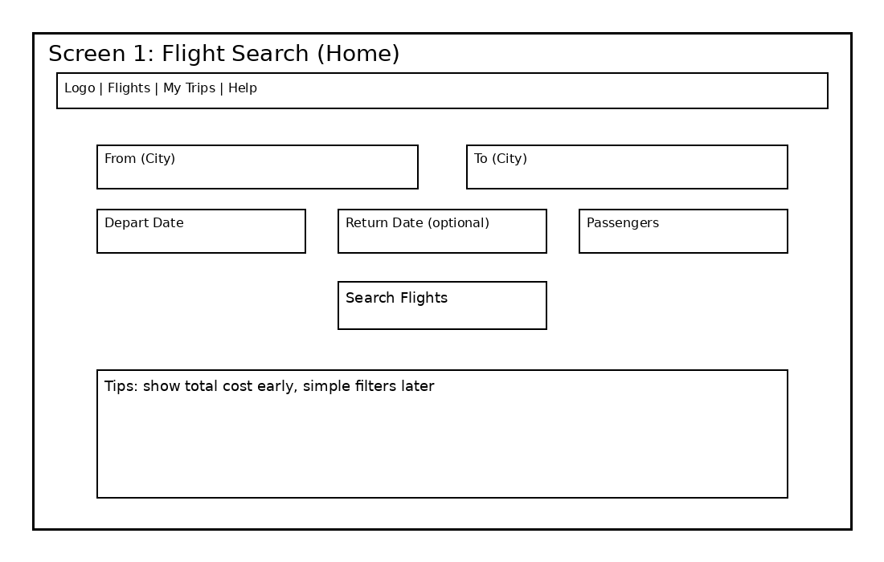
User inputs:
• From city
• To city
• Depart date (and optional return)
• Passenger count
System displays:
• Search results list
• Clear message if no results
• Total cost estimate shown early
Navigation path:
Home → Search Flights → Results

UC-2 Filter + Compare Results
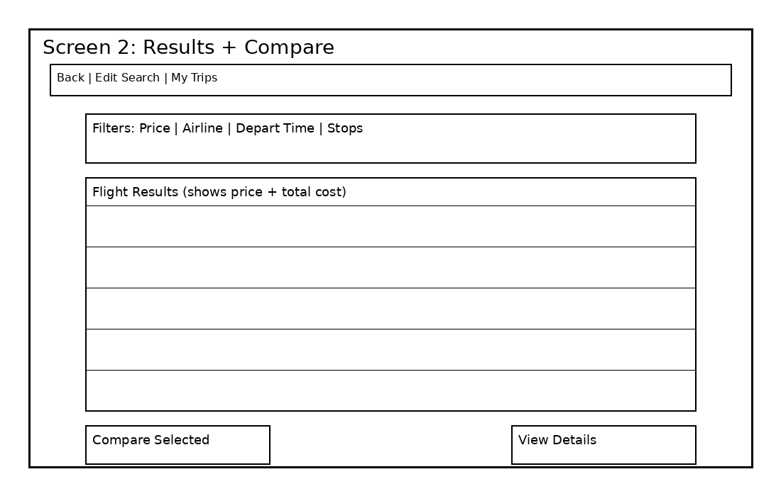
User inputs:
• Filter by price/airline/time/stops
• Select 2–3 flights to compare
System displays:
• Sorted results
• Comparison view
Navigation path:
Results → Filter/Sort → Compare → Flight Details

UC-3 Flight Details + Seat Selection
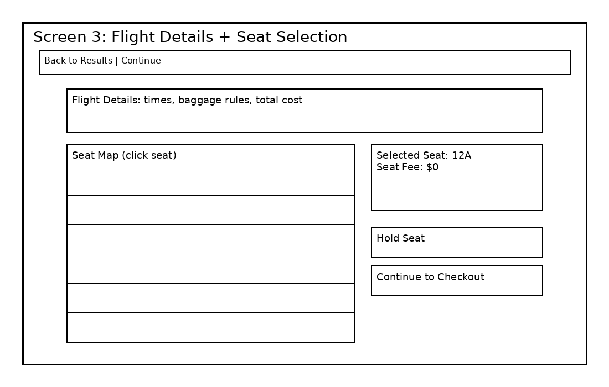
User inputs:
• Select seat from seat map
• Hold seat
System displays:
• Seat availability
• Selected seat + seat fee
• Error if seat taken
Navigation path:
Results → Flight Details → Seat Selection → Checkout

UC-4 Checkout + Payment + Confirmation
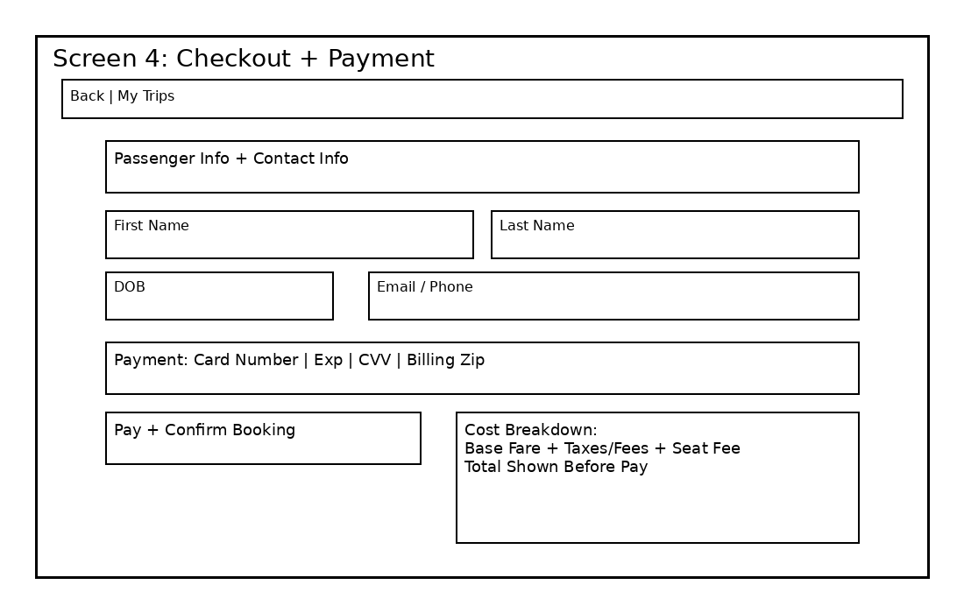
User inputs:
• Passenger name + DOB
• Contact info
• Card payment info
System displays:
• Final total cost (before pay)
• Payment success/fail message
• Booking confirmation + ticket info
Navigation path:
Checkout → Pay → Confirmation → My Trips

UC-5 My Trips: Manage Booking
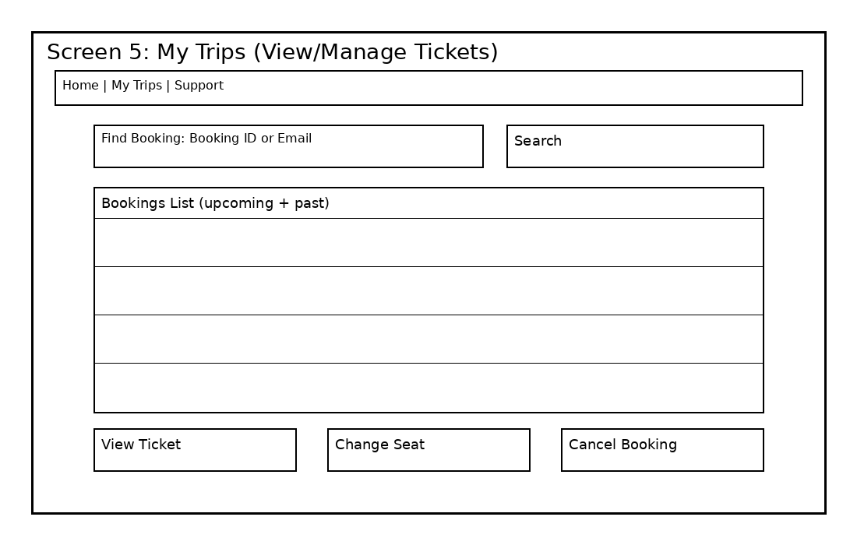
User inputs:
• Search by booking ID/email
• Choose booking
• View ticket / change seat / cancel
System displays:
• Booking list
• Ticket details
• Updated seat or cancellation status
Navigation path:
My Trips → Select Booking → Manage Actions

User Effort Estimation
Below are quick estimates for a few common scenarios. I’m counting clicks on buttons/fields, and rough keystrokes for typed text.
Scenario A: Search a one-way flight and view results
- Click From field (clicks: 1, keys: 0)
- Type 'Indianapolis' (12) (clicks: 0, keys: 12)
- Click To field (clicks: 1, keys: 0)
- Type 'Miami' (5) (clicks: 0, keys: 5)
- Click Depart Date (clicks: 1, keys: 0)
- Pick date (calendar click) (clicks: 1, keys: 0)
- Click Passengers (clicks: 1, keys: 0)
- Choose 1 passenger (clicks: 1, keys: 0)
- Click Search Flights (clicks: 1, keys: 0)
- Click a result to view details (clicks: 1, keys: 0)
Total estimated effort: 8 clicks, 17 keystrokes

Scenario B: Book a flight
- From Results, click View Details (clicks: 1, keys: 0)
- Click a seat (clicks: 1, keys: 0)
- Click Hold Seat (clicks: 1, keys: 0)
- Click Continue to Checkout (clicks: 1, keys: 0)
- Click First Name (clicks: 1, keys: 0)
- Type first name (5) (clicks: 0, keys: 5)
- Click Last Name (clicks: 1, keys: 0)
- Type last name (6) (clicks: 0, keys: 6)
- Click DOB (clicks: 1, keys: 0)
- Type DOB (10) (clicks: 0, keys: 10)
- Click Email/Phone (clicks: 1, keys: 0)
- Type email (15) (clicks: 0, keys: 15)
- Click Card Number (clicks: 1, keys: 0)
- Type card (16) (clicks: 0, keys: 16)
- Click Exp (clicks: 1, keys: 0)
- Type exp (4) (clicks: 0, keys: 4)
- Click CVV (clicks: 1, keys: 0)
- Type CVV (3) (clicks: 0, keys: 3)
- Click Billing Zip (clicks: 1, keys: 0)
- Type zip (5) (clicks: 0, keys: 5)
- Click Pay + Confirm Booking (clicks: 1, keys: 0)
Total estimated effort: 13 clicks, 64 keystrokes

